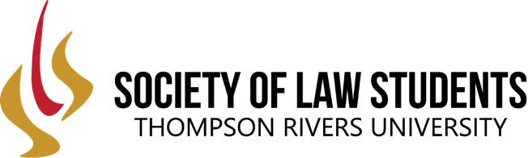
MINUTES
Title of meeting: SLS Executive Meeting
Date: April 25, 2021
Time: 10:00 AM
Location: Zoom Link
(1) Call to Order

Meeting called to order at 10:01 AM

(2) Roll Call

Ian Pham
Abbey Fortin
Kyle Komarynsky
Jatinder Gill
Arjun Dhaliwal
Madeleine Keating
Paige Zambonelli
Ben Turner
Azat Perengliyev
Harsh Kang
Baljinder Bains

(3) Approval of Minutes from Last Meeting

All in approval: all in favor, motion passed

(4) President Report (Kyle)

- SLS remaining pass/fail
- Discussion about electives and the ability of students to customize their experience
- Considered how OCI’s will interact with required courses, believe it will work out well with OCI’s returning to September
- Ask the school to send out information to incoming 1L students, so they understand what classes involve
- Motion to accept the changes to the curriculum changes. All in favour, motion passed.
- Will be voted on in the faculty council meeting
- Plans to arrange a meeting with the Deans to discuss concerns about 1L delivery

(5) Reports from Internal Directors

(a) Vice Presidents

(a.1) VP fundraising—Jatinder Gill
No updates

(a.2) VP Academic Ian Pham
No updates

(b) Class Representatives

(b.1) 1L (Azat)
No updates

(b.2) 2L (Maddy)
No updates

(b.3) 3L (Arjun)
No updates

(c) Chair of student life (Harsh)
No updates

(d) Events (Paige)

No updates

(6) External Reports

(a) ILSA (Jamie)
No updates

(b) Communications and Marketing Officer (Abbey)

No updates

(7) Financial Report (Baljinder)

No updates

(8) Conference (Ben)

No updates

(9) Other Business
Closed @ 10:54 AM

